They picked milkweed to help World War II flyers. Now they grow it to help monarch butterflies. | Pittsburgh Post-Gazette
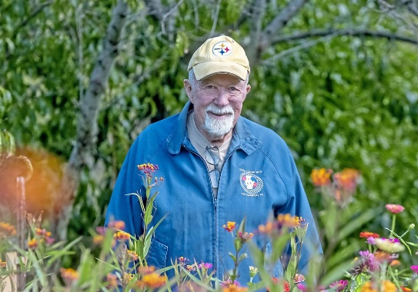
12
MORE

They picked milkweed to help World War II flyers. Now they grow it to help monarch butterflies.

ROBERT PODURGIEL

OCT 14, 2022

4:00 AM
With a couple of burlap sacks slung over his shoulder, and with his pet German shepherd Fritz leading the way, third grader Clyde Seigler scoured the countryside of Brooke County in the West Virginia Panhandle searching for milkweed seed pods.
He laughed at the antics of Fritz as he bounded ahead of him through the open areas where, at that time of the 1940s, milkweed seemed to grow everywhere — along the roads, in ditches, and especially in the hayfields, where farmers would curse the weed.
'just a good thing to do'
Sometimes his younger brother, Ralph, would tag along with Clyde and Fritz, but it was hard for little Ralph to keep up.
Clyde easily could fill one or two burlap bags each trip with milkweed pods that looked like pickles — pale green with bumps on the skin — but what was inside those pods is what he was after.
In September and October each year, the pods would crack open to reveal brown, oval seeds attached to white silky fibers called floss.
Once the pods opened, when stirred by a little wind, the seeds attached to the fluff would float on the breeze like tiny parachutes. If the seeds landed in the right spot, a new milkweed plant would pop up in the spring. Judging by the amount of milkweed, the seed parachutes were an effective way to disperse the seeds.
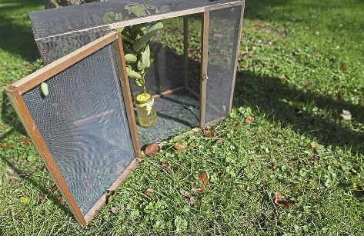Incubator space for butterflies on Clyde Seigler’s farm.(Pittsburgh Post-Gazette)
After Clyde collected about 10 to 12 sacks filled with pods, his dad would toss them into a truck and haul them to Scott Run Elementary School, outside Follansbee, W.Va., where the Seigler boys went to school, and where the sacks would be turned over to the military.
All Clyde knew at the time was that the milkweed fluff had something to do with World War II — that it went into life jackets.
What he didn’t know was that an army of like-minded children was searching the countryside in 25 U.S. states, as well as in Canada’s Ontario and Quebec, to gather milkweed pods in 1942, ’43 and ’44.
Gathering milkweed was not just a public relations, feel-good project to involve children in the war effort. It was an essential part of winning the war.
The country urgently needed the silky floss as fill for life preservers and flight vests. Tests by the U.S Navy had found 1 pound of floss was as warm as wool, but six times as light, and it was six times as buoyant as cork. A pound of floss could keep a 150-pound man afloat for more than 40 hours. During the war, children such as Clyde Seigler collected enough floss to fill more than 1.2 million life vests for America’s fighting men and women, saving thousands of lives.
Prior to the Japanese attack on Pearl Harbor on Dec. 7, 1941, the fill for most life preservers and flight vests came from the island of Java in the Dutch East Indies, harvested from the pods of the ceiba tree. A cotton-like fiber called kapok also was water resistant and buoyant, but the Japanese captured Java soon after Pearl Harbor, cutting off the supply.
At the same time, the huge influx of men and women into the service required an abundant new source of fill for life preservers and flight vests, which were especially vital because much of the war was being fought over and in the waters of the Atlantic and Pacific oceans.
An enterprising physician and inventor in Chicago named Boris Berkman came up with the solution.
Long an advocate of the many benefits of milkweed, ranging from making pressed board and insulation to surgical dressing, he had filed a patent application in 1939 for a milkweed gin to process the plant.
When the call went out from the War Department in early 1942 to find a substitute for kapok, Berkman was ready. He believed milkweed floss would work better than kapok as a filler for life preservers. He presented his case for milkweed floss before a congressional agricultural committee in March 1942. Based on the tests conducted by Berkman and the Navy, the government declared milkweed a “wartime strategic material.”
Now with government funding and encouragement, Berkman set up a processing plant in Petoskey, Mich., and the call went out across the United States to gather wild milkweed. Boy Scouts, school children and even the Roman Catholic nuns at Holy Cross School answered the call.
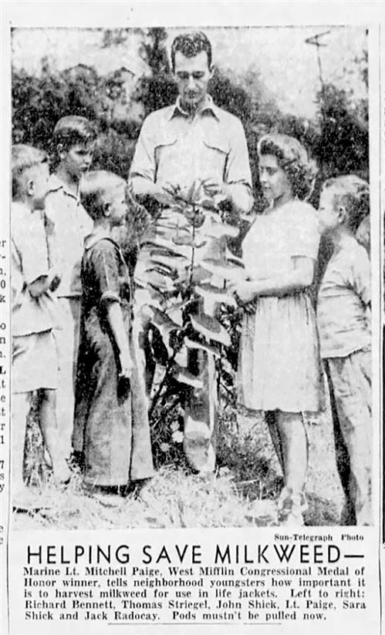During World War II, Pittsburgh children helped collect milkweed floss to use in soldiers' and sailors' life vests.(Courtesy of the Senator John Heinz History Center )
Soon sacks of milkweed were pouring into the Petoskey processing plant. The Navy initially requested 200,00 pounds of milkweed floss in 1942, then ordered another 100,000 pounds. Twenty pounds of milkweed floss was required, or roughly two bags full of pods, to make one life jacket.
The government came up with the slogan, “Two Bags Save One Life.”
Rear Adm. E.L. Cochrane, chief of the Navy’s Bureau of Ships, urged citizens “who want to contribute directly to victory and save the lives of American fighting men” to collect milkweed.
Although 85 species of milkweed grow in North America, the best fluff for life jackets came from the species Asclepias syriaca, or common milkweed, which grew profusely the Midwestern and Eastern states including Michigan, Ohio, West Virginia and Pennsylvania.
Demand for floss would increase exponentially. In 1943, the Navy alone ordered 1.5 million pounds of floss. By 1944, the war effort required 3 million pounds of floss, meaning the children and volunteers faced the daunting task of collecting 30 million pounds of milkweed pods.
Western Pennsylvania school children and volunteers went to work. The Pittsburgh Sun-Telegraph newspaper launched a “milkweed drive,” offering $500 in prizes. An ad in the paper asked young people to become members of the Sun-Telegraph Junior Victory Army, who when they signed the pledge, would promise “that all of the precious milkweed in my neighborhood is not destroyed and that it is harvested at the proper time. I do this as my help in keeping the production life jackets for our fighting men at top peak.”
Hundreds of children signed the pledge.
Western Pennsylvania proved a good region for harvesting milkweed. Not only was the City of Pittsburgh surrounded by farm fields and sunny hillsides where milkweed thrived, but also the hardy plant also grew in vacant lots and along roadsides in the industrial heart of the city and the Mon Valley.
The Sun-Telegraph published photos of children from Duquesne Heights carefully constructing protective enclosures around wild milkweed growing in a vacant lot.
In another photo from the Sun-Telegraph, Medal of Honor recipient Marine Lt. Mitchell Paige shows children from West Mifflin how to care for and harvest milkweed.
As the demand for milkweed continued to grow, the government would often pay a bounty for the pods. The going rate became 20 cents a bag.
Reflecting on his days collecting milkweed in the West Virginia countryside, 84-year-old Clyde Seigler said he didn’t take any money.
“It was just a good thing to do. Everyone wanted to help the war effort. It was a serious time,” he said.
He remembers farmers contributing to scrap metal drives by pulling old rusty tractors out of fields — the same fields where milkweed flourished.
Not many people now remember the milkweed drives. Ralph Siegler, 81, didn’t find out the significance of World War II milkweed collection until this June when he stopped at the Carnegie Borough Building to pick up some free milkweed plants the borough was giving away as part of the Mayors Monarch Pledge, an effort by mayors in the United States, Canada and Mexico to restore habit for the monarch butterfly.
As people chatted about the benefits of milkweed, a Carnegie Shade Tree Commission member mentioned how milkweed helped saved the lives of American servicemen during World War II, triggering his boyhood memory of collecting milkweed with Clyde.
“I never knew what it was for,” he said, happy to find out that as a young child he had helped his country and played a role in saving lives.
He knows something about the importance of doing good and helping others.
For 33 years, he was the cameraman for the “Mister Rogers’ Neighborhood” show filmed at the WQED Studios in Oakland. “I did a little bit of everything, lighting, editing and camera work,” he said. “I was there from the first day until the last day of the show.
His brother Clyde, meanwhile, had a 40-year career at US Airways, where he worked as an airplane maintenance inspector.
Both men, now in their 80s, love to spend time outdoors, harkening back to their days growing up on 3 West Virginia acres, where their mother and father raised chicken, pigs and cattle to help feed the family.
Today Clyde, who lives in Clinton, and Ralph, who lives in Oakdale, still have a strong connection to the land.
Every year both men plant large vegetable and flower gardens on their property, and they also grow milkweed to help save monarch butterflies. Monarchs were recently placed on the endangered list by the International Union for the Conservation of Nature.
Milkweed, it turns out, is vital to monarchs. They lay their eggs on the plant, and its leaves are the caterpillars only source of nourishment before they build a chrysalis and emerge as new butterflies. Milkweed flowers also provide nectar to fuel the mature monarchs on their yearly migration from Mexico through the United States into Canada.
“When I found out the butterflies were endangered, I wanted to help out any way I could,” said Clyde, who grows milkweed on the 12 acres he owns in Clinton, where he also maintains several flower beds of nectar plants. One bed is 8 feet wide and 25 feet long and is filled with zinnias. “The butterflies are attracted to the nectar in the zinnia, then they lay their eggs on the milkweed plants,” he said.
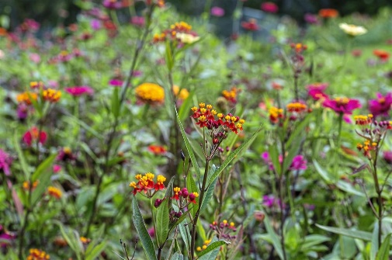Milkweed and Zinnia’s bloom on the farm.(Pittsburgh Post-Gazette)
Once abundant, milkweed is now relatively scarce in Western Pennsylvania and other parts of the country. Suburban sprawl has converted farm fields into housing developments and commercial districts. Indiscriminate spraying of herbicides kill milkweed along roadsides and railroad right of ways.
Monarch populations have fallen by almost 90 percent in recent years. Clyde Seigler said he noticed a drop in monarch numbers this year, but he and his brother are working with milkweed to help reverse this trend in hopes of saving some flyers of a different kind than they and thousands of other children helped more than 70 years ago.
Bob Podurgiel is a freelance writer who lives in Scott: robertpod2017@gmail.com.

First Published October 14, 2022, 4:00am

